CNT3004: Computer Network Concepts
Homework 5&6

(100 pts total) Answer each of the following questions and/or complete the required task. You will be installing some software on your system, but it is safe. Put ALL your answers into 1 file (word, or pdf).

- (20 pts) Identify and define the following 5 security certifications (you will need to use the Internet):
CERTIFICATION | WHAT IT STANDS FOR | BRIEF DESCRIPTION | WHO DEVELOPED AND/OR MANAGES THE CERTIFICATION
CEH | Certified Ethical Hacker | Certificate for demonstrating knowledge of tools used by hackers | EC
CISM | Certified Information Security Manager | Certificate for demonstrating knowledge of developing an enterprise information security program | ISACA
SECURITY+ | Security + | Certificate for demonstrating possession of skills relating to core security functions and IT career knowledge | CompTIA Security+
CISSP | Certified Information Systems Security Professional | Certificate for demonstrating knowledge of advanced information security skills | International Information System Security Certification Consortium
CISA | Certified Information Systems Auditor | A global standard for a professional in information systems | ISACA

- (20 pts) List and define the following 5 Network Risk Management Software Products (use the Internet to find answers):
RISK MANAGEMENT SOFTWARE | BRIEF DESCRIPTION (WHAT IT DOES/HOW IT WORKS) | WHO DEVELOPED AND/OR MANAGES THE SOFTWARE
LogicGate Risk Cloud | Software that provides end-to-end application flexibility and functionality to manage an entire organization’s risk | Cloud Based Governance
SecurityScorecard | Software that provides cyber security and risk details in a comprehensive 360-degree manner | Aleksandr Yampolskiy
Fastpath Assure | Software that provides security tools and a method for auditing duties | Fastpath
SAI360 | Software used to navigate risks in an organization | SAI Global
SureCloud | Software that provides risk management solutions | Richard Hibbert Richard

- (20 pts) Identify the following 5 WAN technologies.
WAN TECHNOLOGY | DESCRIPTION | HOW IS IT USED
ATM | A switching technique used by telecom networks that allows for a wide range of communication support | It asynchronous time division multiplexing to encode data into small, fixed-size portions
FRAME RELAY | A standardized WAN that specifies the physical and data link layers of digital telecom channels using packet switching | Used to connect LANs with major traffic connections. Is not good for voice or video due to how it handles the connection
SONET | A communication protocol that transmits multiple data streams at the same time over optical fiber | Used for large scale data transfers. If Frame Relays were a sidewalk in a rural neighborhood, SONET would be a highway.
MPLS | A packet-switching technology that forwards data from one source to its destination using labels instead of IPs | Generally used for telecom traffic engineering.
SATELLITE | Encrypted connections that can be made anywhere a satellite has coverage | Used largely in areas where standard infrastructure is not available, like an airplane or an out of the way town.

- (40 pts) You will be running programs on your Windows Machine (if you have a Mac you will need to dual boot Windows on your machine if you have not done so already or use the MAC tools that are similar, go to https://support.apple.com/guide/activity-monitor/welcome/mac).
  - Type MMC in the search field (left bottom of screen).
  - The Microsoft Management Counsel will appear named Console1 in the upper left of the window.
  - Click on File and then Add/Remove Snap In.
  - Add the following Snap-in(s)
    - Device Manager
    - Event Viewer (for the local computer)
    - Services (for the local computer)
  - Then click on OK. All three tools will be showing. Take a screen shot showing that they are all in the MMC.
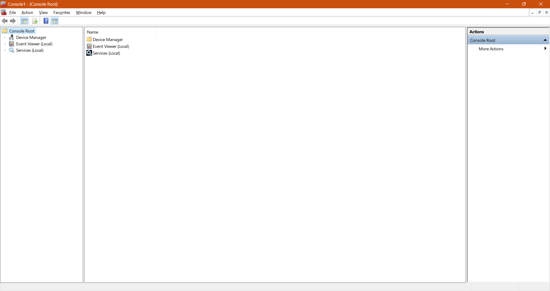
  - Next, click on Device Manager and a list of devices will show. Take a screen shot of this.
    - Click on Computer icon and then the computer name listed. You should get another window with the tabs: General, Driver, Details and Events. Take a screen shot of this.
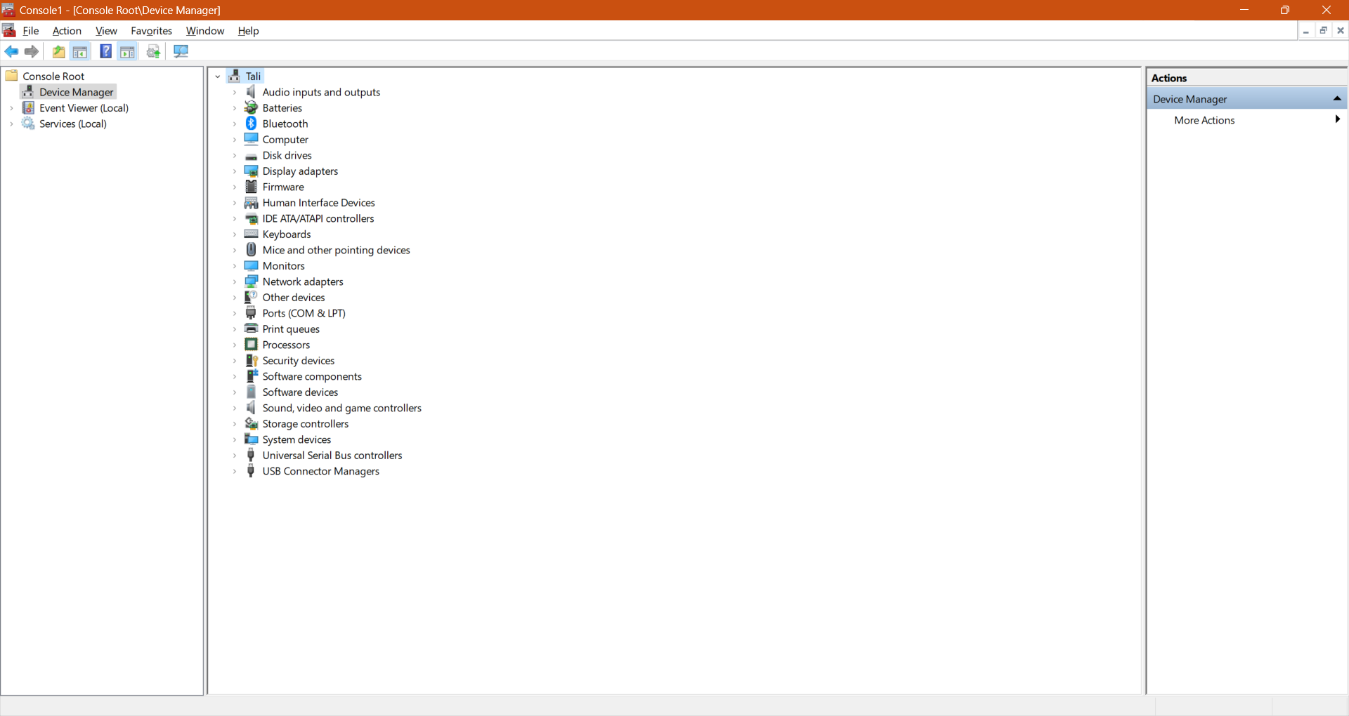
  - Next, click on Event Viewer (Local) – you should see an Overview and Summary window (take a screen shot of this).
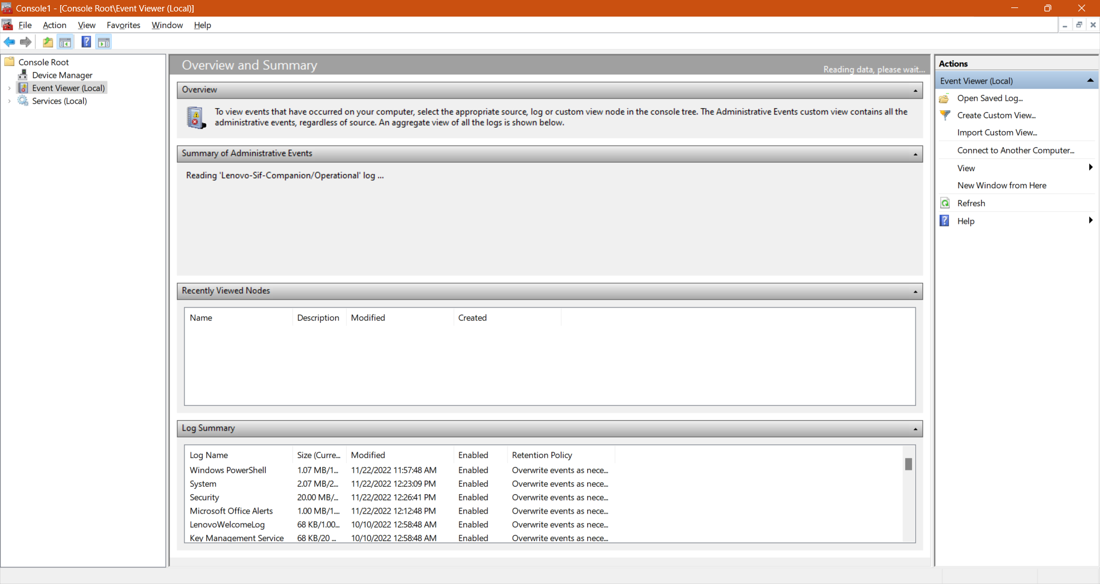
    - Click on the System log in the Windows Logs folder. There are Levels of errors. What are they? __10010_______________, ______7031___________, ______7024________
    - Click on one of the items in the System Log file and take a screen shot (it should open a new window with the General and Details tab.
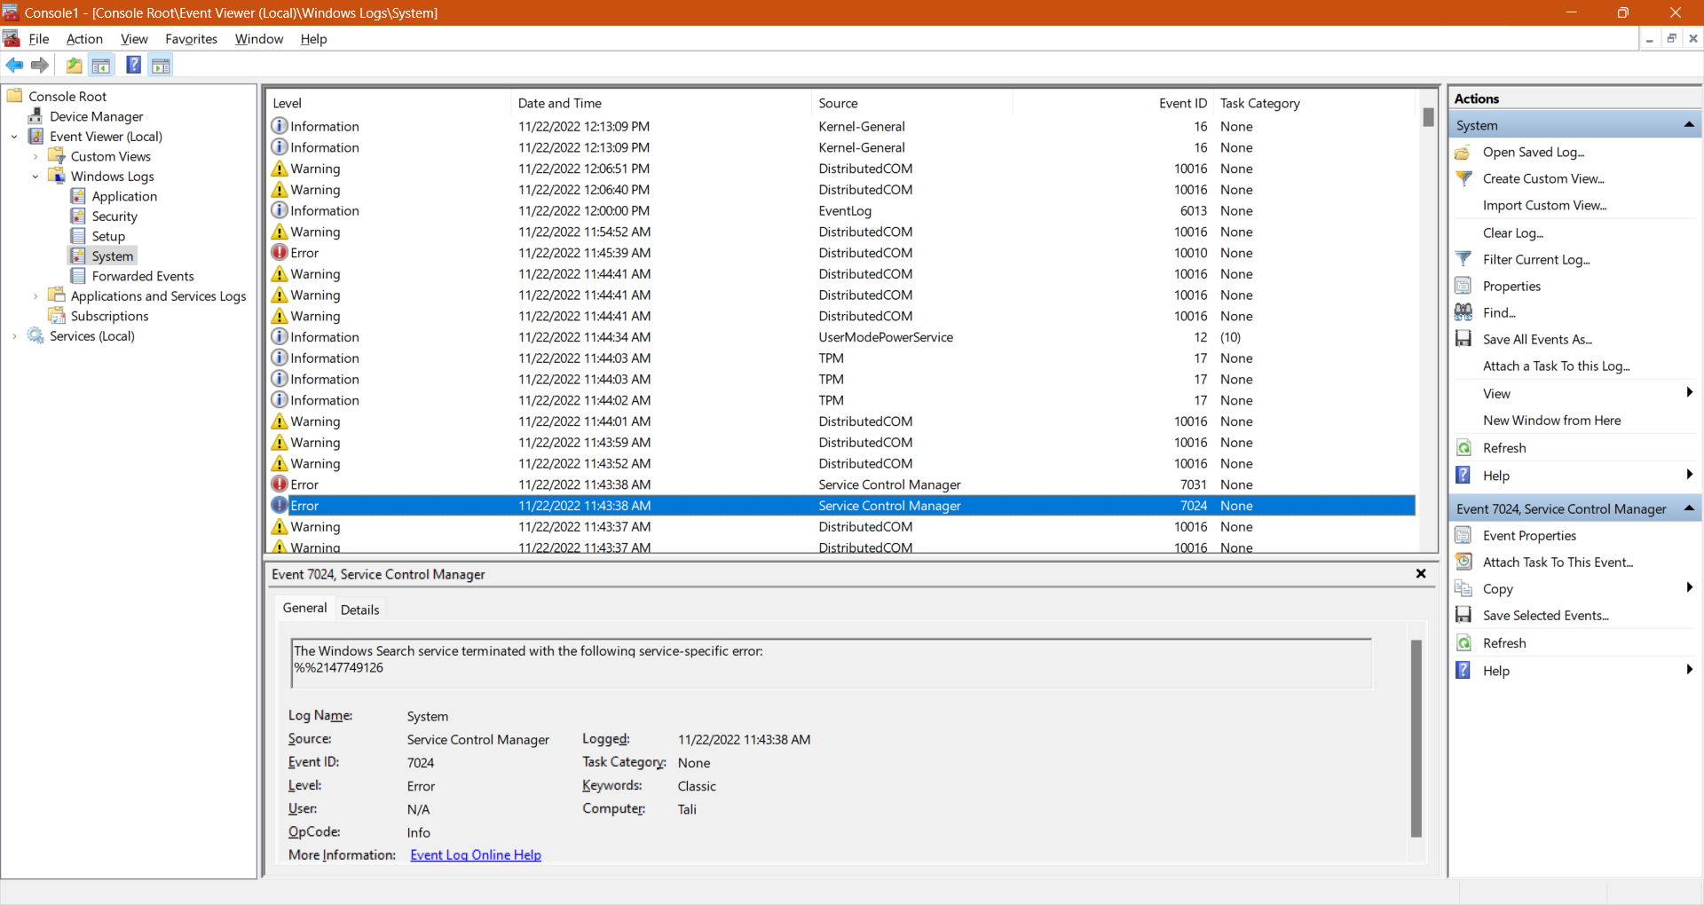
  - Lastly, click on Services (Local) and take a screen shot of the window (should show the Name of the services on your system).
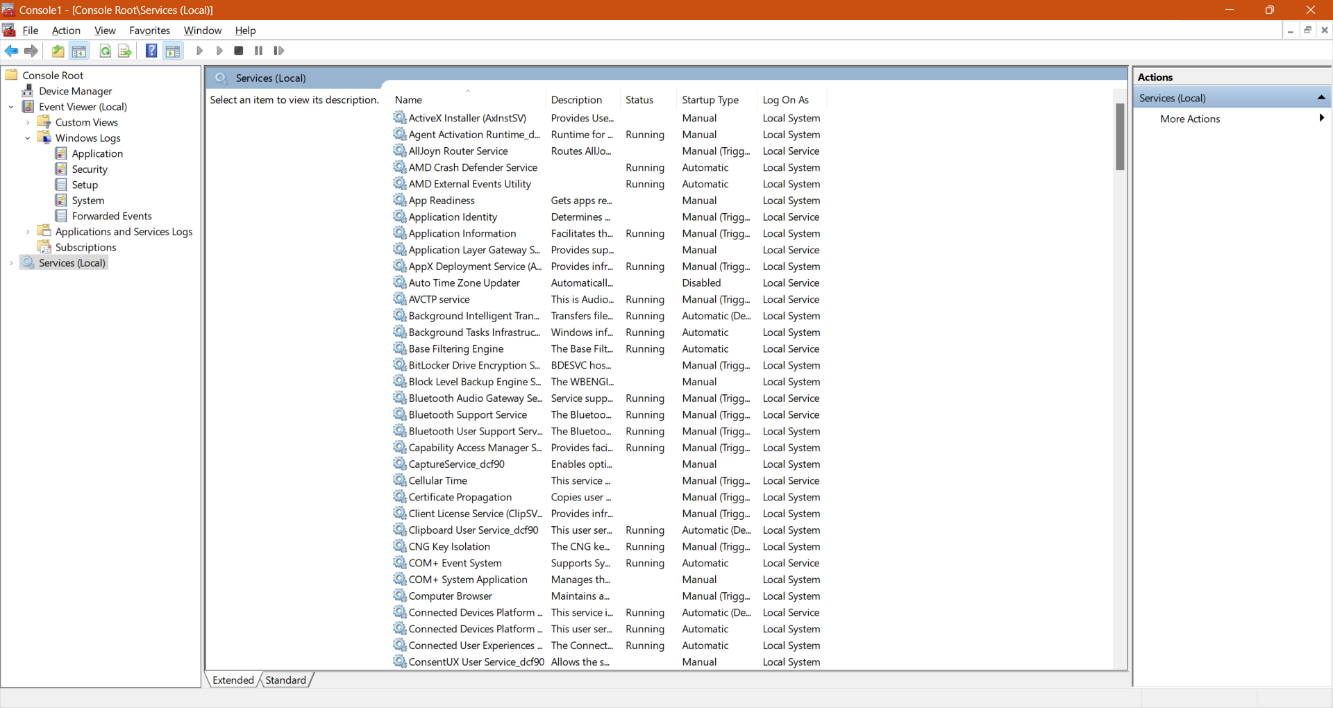
  - You can click on ANY of the services to get a more detailed explanation. Click on one of these processes and take a screen shot.
